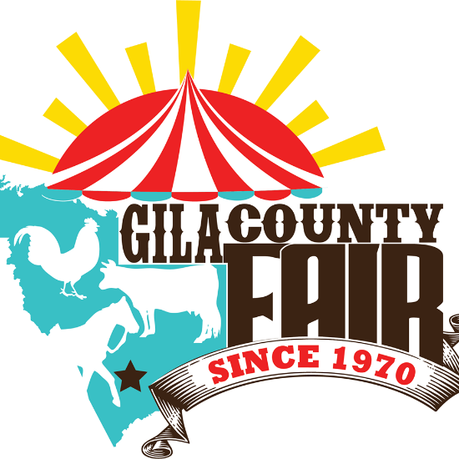

____________________________________________
Name of Exhibitor

Gila County Fair
Entry Packet
BREEDING LIVESTOCK DIVISION

Exhibitor Checklist:
__________ Entry Form
__________ ADA Seasonal Pass
__________ Certified Health Inspection
__________ National Code of Show Ring Ethics
__________ Media Release Form
__________ Rate of Gain Form

Gila County Fair
CATTLE
Breeding Animal Show Entry Form
***
All Entries due July 1 at 5pm.
NO LATE ENTRIES WILL BE ACCEPTED!

Please check the following age category: Please check the following department:
Junior Senior FFA or 4-H Open
(9-13yrs) (14-19yrs) Dept. K Dept. A

Exhibitor Name: ____________________________

Address: ______________________________ Phone: ____________ Email: _______________________

City: __________________________ Zip: _________ Birthdate: ______

FFA Chapter: __________________ 4-H Club: __________________ Open Group: __________________

BREED AGE D.O.B. FEMALE BULL TAG # DESCRIPTION

**Please use an additional form for multiple entries.
Exhibitors of large livestock may enter one (1) entry per class**

I hereby request permission to participate in the Gila County Fair Livestock Show. I have read and fully understand the Livestock Rule Book, Media Release and the Code of Conduct. I agree to abide by the rules of the Livestock Show and I will accept the decision of the judges and Fair Management as final. I also agree to conduct myself in a sportsmanlike manner at all times.

Signature of Exhibitor _____________________________

Signature of Parent/ Guardian ___________________________________

Signature of FFA Advisor or 4-H Leader ___________________________________

---------------------------------- Put these dates on your Calendar---------------------------------
Entries are due July 1, 2019 by 5pm to your leader/advisor, or to the Coop Extension Office, or the Copper Admin Office at 1400 E Ash St. Building 1350.
Breeding Cattle will be received at the Fair on Wednesday, September 18th from 2:00-7:00 pm.
Breeding Cattle Show is on Friday, September 20th at conclusion of Market cattle show (approx. 11am)

Gila County Fair
GOAT/SHEEP
Breeding Animal Show Entry Form
*** ***
All Entries due July 1 at 5:00pm.
NO LATE ENTRIES WILL BE ACCEPTED!

Please check the following age category: Please check the following department:
Junior Senior FFA or 4-H Open
(9-13yrs) (14-19yrs) Dept. K Dept. A

Exhibitor Name: ____________________________

Address: ______________________________ Phone: ____________ Email: _______________________

City: __________________________ Zip: _________ Birthdate: ______

FFA Chapter: __________________ 4-H Club: __________________ Open Group: __________________

Herd Registration or Scrapie Tag Number: _________________

BREED BUCK DOE WETHER TAG # OR TATOO D.O.B.
GOAT
SHEEP

**Please use an additional form for multiple entries.
Exhibitors of large livestock may enter one (1) entry per class**

I hereby request permission to participate in the Gila County Fair Livestock Show. I have read and fully understand the Livestock Rule Book, Media Release and the Code of Conduct. I agree to abide by the rules of the Livestock Show and I will accept the decision of the judges and Fair Management as final. I also agree to conduct myself in a sportsmanlike manner at all times.

Signature of Exhibitor _____________________________

Signature of Parent/ Guardian ___________________________________

Signature of FFA Advisor or 4-H Leader ___________________________________

---------------------------------- Put these dates on your Calendar---------------------------------
Entries are due July 1, 2019 by 5pm to your leader/advisor, or to the Coop Extension Office, or the Copper Admin Office at 1400 E Ash St. Building 1350.
Goat/Sheep will be received at the Fair on Wednesday, September 18th from 2:00-7:00 pm.
Goat/Sheep Show is on Thursday, September 19th-time to be determined by number of entries.

GILA COUNTY FAIR AND EXPOSITION
STATEMENT OF UNDERSTANDING

Exhibitor:
I hereby request permission to participate in the Youth Livestock Show at the Gila County Fair and Exposition. I have read and fully understand the rules. I agree to abide by the rules of the Livestock Show and I will accept the decisions of the judges and the Livestock Committee as final. I also agree to conduct myself in a sportsmanlike manner at all times.
_______________________ _______________________ ____________
Printed Name of Exhibitor Signature of Exhibitor Date

Parent/Guardian:
I have consented for my child to enter the Youth Livestock Show at the Gila County Fair and Exposition. I have read and discussed the rules with my child and fully understand them. I agree to abide by the rules of the Livestock Show and I will accept the decisions of the judges and the Livestock Committee as final. I also agree to conduct myself in a sportsmanlike manner at all times.

_______________________ _______________________ ____________
Printed Name of Parent Signature of Parent Date

Media Release Statement
The Gila County Fair & Exposition, Inc. periodically uses electronic and traditional media (e.g., photographs, video, audio footage, testimonials) for publicity and educational purposes. By my signature on this form, I acknowledge receipt of this document and give permission to the Gila County Fair & Exposition, Inc. and its designee to use such reproductions for educational and publicity purposes in perpetuity without further consideration from me.

I understand that I will need to notify The Gila County Fair & Exposition, Inc. if any changes to my situation occur that will impact this media release permission. I have read the above release and am aware of its contents.

Signed ______________________________________ Date _____________________

Printed Name___________________________________________________________

Address _______________________________________________________________

Signature of Parent or Guardian (if under 18) - I am the guardian of the minor named above and hereby agree that we will be bound by this release:

Signed ______________________________________ Date _____________________

